ABachata

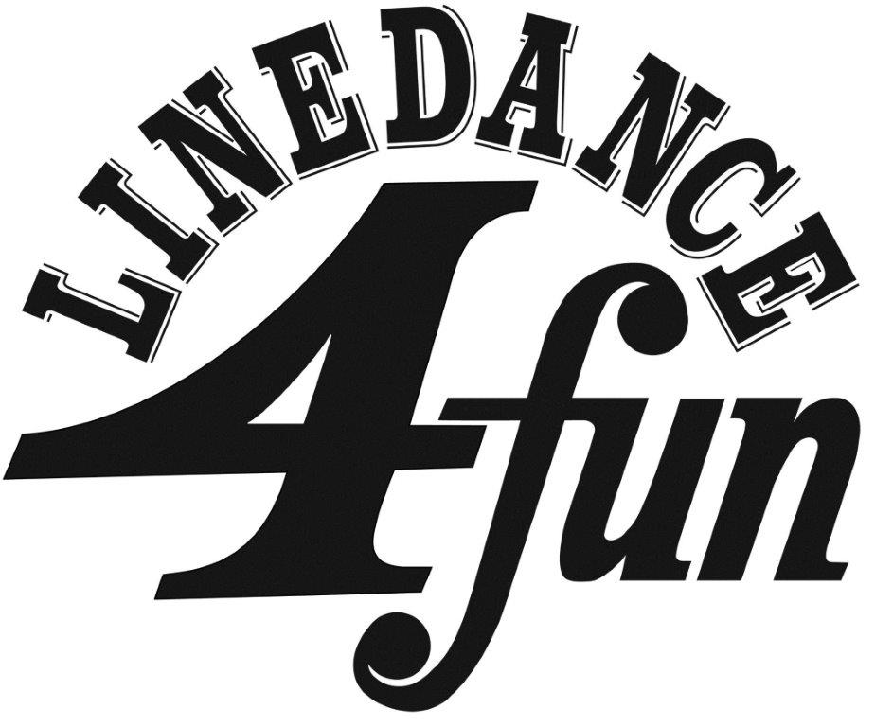
Level: Absolute Beginner Count: 32 Wall: 4
Choreographer: Ross Brown (UK) (Nov 2014 )
Music: I Swear by Voz A Voz. CD : I Swear [Length – 4:25]
Style: West Coast Swing

Intro : 64 Counts (Approx. 30 Secs)
RUMBA BOX FORWARD.
1 – 2 Step forward with right, touch left next to right.
3 – 4 Step left to the left, step right next to left.
5 – 6 Step back with left, touch right next to left.
7 – 8 Step right to the right, step left next to right. (12 O’CLOCK)
STEP, KICK. BACK, TOGETHER. X2.
1 – 2 Step forward with right, kick left foot forward.
3 – 4 Step back with left, step right next to left.
5 – 6 Step forward with left, kick right foot forward.
7 – 8 Step back with right, step left next to right. (12 O’CLOCK)
STEP, POINT. STEP, POINT. WEAVE LEFT.
1 – 2 Step forward with right, point left to the left.
3 – 4 Step forward with left, point right to the right.
5 – 6 Cross step right over left, step left to the left.
7 – 8 Cross step right behind left, step left to the left. (12 O’CLOCK)
JAZZ BOX ¼ TURN R with CROSS. SWAY, SWAY. TOGETHER, STEP FORWARD.
1 – 2 Cross step right over left, make a ¼ turn right stepping back with left.
3 – 4 Step right to the right, cross step left over right.
5 – 6 Step right to the right swaying right, sway left.
7 – 8 Step right next to left, step forward with left. (3 O’CLOCK)
END OF DANCE!

